Lab name：**Power Amplifier** Student ID： B11102112 Name: Chiajui Lee

# Purpose

A power amplifier is an electronic circuit that amplifies weak signals to sufficient power levels, with applications in audio and RF amplification. Through experiments, we study its basic principles:

* Classification of amplification stages
* Operating states and characteristics
* Design considerations like gain, output power, efficiency, and distortion

The experiments also teach fundamental design methods:

* Selecting amplification stages
* Setting bias voltages
* Matching load impedance

# Steps

1. Construct the circuit as specified in the problem using operational amplifiers (OPAs), bipolar junction transistors (BJTs), capacitors, and resistors.
2. Connect the power supply to provide +6V to pin 8 (𝑉CC) and -6V to pin 4 (𝑉EE) of the operational amplifier (OPA).
3. Measure the output results using an oscilloscope.

# Data

## Power Amplifier (Distortion)

* 1. Circuit diagram

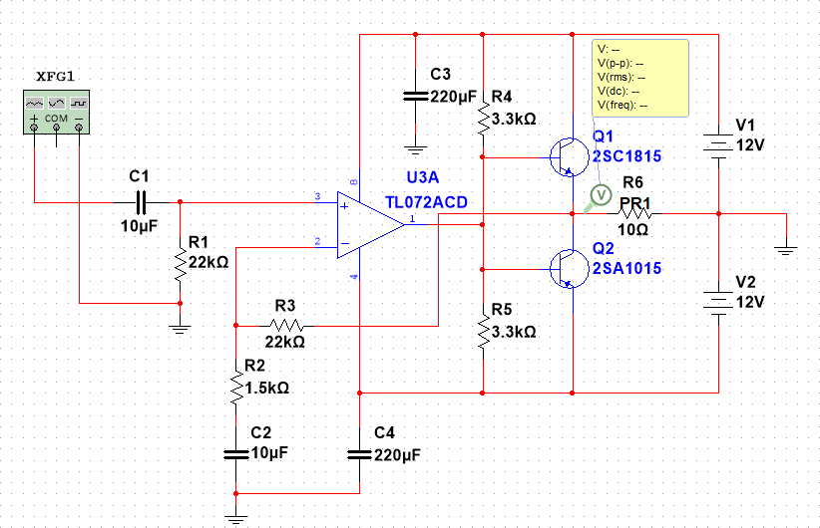

* 1. Output waveform (Distortion)

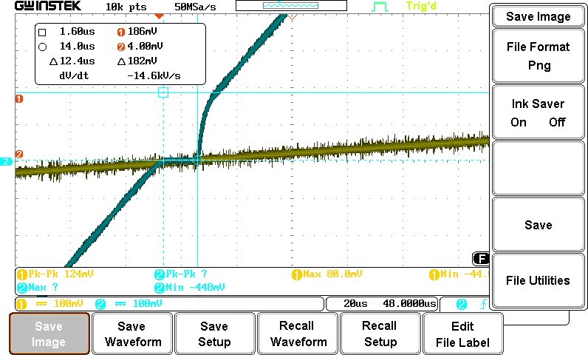

## Power Amplifier (Distortion-Free)

* 1. Circuit diagram

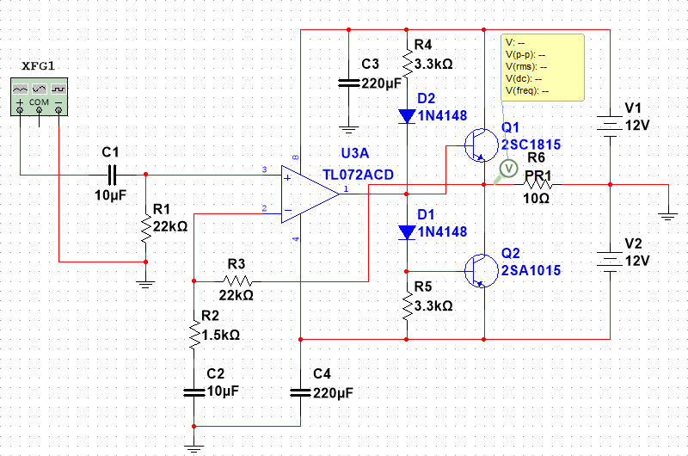

* 1. Output waveform

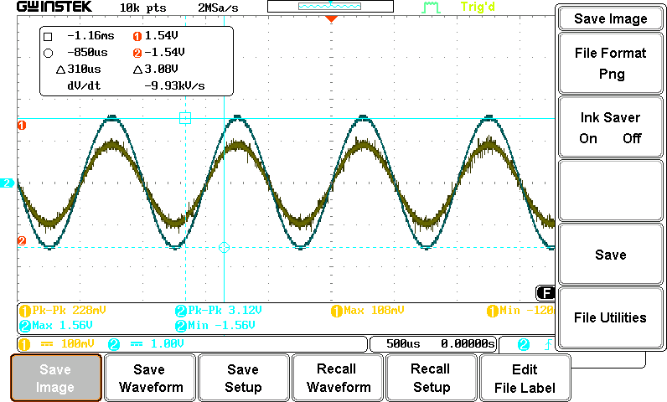

* 1. Output data

|  |  |  |
| --- | --- | --- |
|  | Measured Value | Theoretical Value |
| Magnification | 13.448 V/V | 15.6 V/V |
| Max output power | 0.121W | |
| Max undistorted amp. | 190mV | |

# Questions and Discussion

## Why does adding diodes at the output of an OPA help solve crossover distortion?

Crossover distortion occurs when an amplifier's output signal transitions between positive and negative saturation, particularly near zero-crossing points, due to output devices (e.g., BJTs) failing to instantly enter their linear operating region. Diodes address this by:

1. **Fast Switching**: Their rapid response (ns-scale) bridges the transition gap.
2. **Low Threshold Voltage**: Schottky (0.3V) or silicon (0.7V) diodes conduct early, minimizing dead zones.
3. **Current Path Provision**: They maintain conduction during BJT turn-on delays.

**Result**: Smoother transitions into the linear region, reducing distortion.

# Reflections

This power amplifier experiment left a deep impression on me. While I had encountered similar circuit principles in high school, the hands-on implementation presented significant challenges. The circuit's complexity compared to previous designs required substantially more time and effort. During construction, I meticulously studied the schematic to understand each component's function and repeatedly verified connections for errors.

Several issues arose, including:

* Improper component selection
* Wiring mistakes

Through persistent troubleshooting, I ultimately succeeded in completing the experiment.

The bonus task continued the practical approach by focusing on real-world audio-output circuits. This exercise taught me how to amplify weak audio signals to power levels sufficient for driving speakers, demonstrating the direct application of electronic theory to everyday technology.